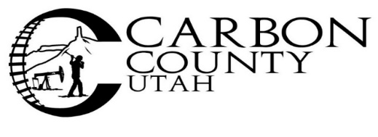

BID NOTICE

The Carbon County Sheriff’s Office will accept sealed bids for one (1) vehicle with specifications as listed:

Medium or Full Sized four-wheel drive or all-wheel drive SUV
New or used with fewer than 20,000 miles
No major accidents
Police package or Special Service package preferred, but not required
Color preferences are black, silver, charcoal, grey or white
Preference will be given to vehicles that are commonly used as patrol vehicles such as Ford Explorer’s and Dodge Durango’s, due to compatibility with upfitting equipment.

All options and other features as well as maintenance and warranty information must be included with bid(s). Vehicle must be in stock and ready for pick up.

Bids are due no later than 4:30 p.m. October 31, 2023 and must be submitted to the Carbon County Clerk/Auditor’s Office at the Carbon County Administration Building located at 751 East 100 North, Price, Utah 84501.

Bid opening date will be November 1, 2023 at a regular scheduled commission meeting beginning at 4:30 pm in the Commission Chambers of the Carbon County Administration Building, 751 East 100 North Price Utah.
Carbon County is not responsible for bids that are received late due to delays in delivery by any source.

Faxed and emailed bids are NOT accepted.

PLEASE NOTE: On the outside of a sealed envelope for each vehicle write:
“Police Vehicle”

Carbon County reserves the right to reject any or all bids, to waive any informality of any bid and select the bid, which in the opinion of the County, provides the best product, warranty and/or service for the County.

For more information please contact the Carbon County Sheriff’s Office at (435) 636-3251.

