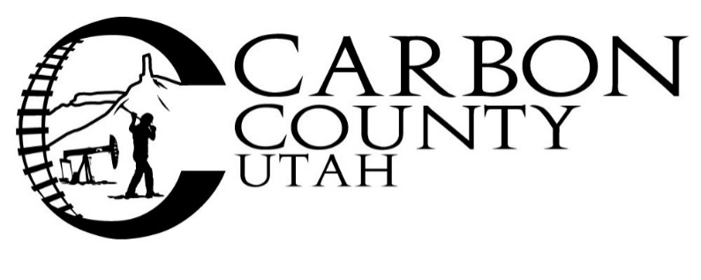
Bid Notice
Carbon County Road Department will accept sealed bids for paint-striping of up to 1,000,000 linear feet of paint lines on County roads. Must be painted to meet UDOT standards STPR499 (6), Section 02765S, 4” and 6”. Bid needs to include all costs including any trucking or setup costs. Mobilization and Demobilization or any other cost associated must be included.
Bids are due at the Carbon County clerks’ office at 751 East 100 North Suite #1100 Price, Utah 84501, prior to 3:00 p.m. on February 15, 2023. Bids will be opened during the regularly scheduled Carbon County Commission meeting at 4:30 p.m. on February 15, 2023 at the aforementioned address in the Commission Chambers.
Carbon County is not responsible for bids that are late due to delays in delivery by any source. Faxed and emailed bids will NOT be accepted.
PLEASE NOTE: On outside of a sealed envelope write:
2023 Paint-Striping Bid for Carbon County Road Department
Carbon County reserves the right to reject any or all bids, to waive any informality of any bid and to select the bid which in the opinion of the County provides the best product, warranty and/or service to the County.
For further information please call the Road Department at 435-636-3268 between 7:00 A.M. and 5:30 P.M. Monday through Thursday.

