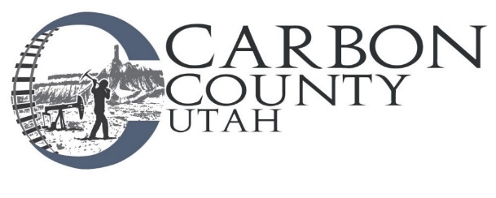

**Bid Notice**

**2023 Carbon County Landfill Scrap Metal Removal**

Carbon County is accepting proposals for the purchase and removal of all scrap metal from the Carbon County Landfill through December 31, 2023.

The proposal should state the price that will be paid to the County to remove metal, or the manner in which the price will be calculated. Scrape Metal must be removed every Quarter. CFCs shall not be removed at the landfill but must be removed at contractor’s place of business and processed per applicable Federal and State rules and regulations; Contractor must be licensed to process CFCs. No crushing or bailing on site. All current metal to be removed within one month of award of bid and thereafter as requested, within a month of the request. Proposal should state type of equipment that will be used to remove metal, past experience in processing scrap metal, and references. County may require posting of bond.

Bids are due at the Carbon County Clerks’ office at 751 East 100 North Suite 1100, Price, Utah 84501, prior to 3:00 p.m. on February 15, 2023 and will be opened at a regularly scheduled Commission Meeting beginning at 4:30 p.m. on February 15, 2023. Faxed and e-mailed bids will NOT be accepted. Carbon County is not responsible for proposals that are received late due to delays in delivery by any source

**PLEASE NOTE: On the outside envelope write:**

**2023 Scrap Metal Removal Bid for Carbon County Landfill**

Carbon County reserves the right to reject any or all bids, to waive any informality of any bid and to select the bid which in the opinion of the County provides the best product, warranty and/or service to the County.

For more information please contact Carbon County Road Department at

435-636-3268 Monday through Thursday 7:00 am to 5:30 pm